CASE STUDY ONE

members:  
SeifEldin Mohamed hashem 19105145

Ahmed Waleed Fahmy Ali 19100838

Mohammed Ahmed Abdelrahim Elemary 19104825

**Case study**

You arranged an internship at a local pharmaceutical company with a team working on strategies for inhibiting venom binding to the enzyme acetylcholinesterase. This enzyme breaks down the neurotransmitter acetylcholine at the synaptic cleft (the space between the two nerve cells) allowing transmission of subsequent nerve impulses. The green mamba and other venomous snakes produce a deadly toxin, which is an inhibitor of acetylcholinesterase. You need to design a drug target to prevent the interaction between the toxin in snake venom and acetylcholinesterase. You may use the ray fish Acetylcholine Esterase with pdb **1ACJ.**

**steps**

Our case study, we have protein 1ACJ (Acytocholinestrase), we separated the ligand (tacrine) from the protein by using Pymol.

Then we saved each molecule in separated file in *PDB* format.

Then we converted these formats into PDBQT format using OpenBabel.

and we saved the protein in *target* file, and the ligand in the *ligands* file, with the other ligands that are retrieved from ligands database as PubChem or zinc15.

by using autodocktools, we applied the grid box, then extracted grid box dimensions.

now our files are ready for docking to run python script, to have the best affinity score to take the best ones to apply visualization

after choosing the best three ligands we make visualization on them by measure the length of the ligand and the chain

**output.csv files**

we make it in three separate files

**Best three affinity scores:**

Ligands 17: - 10.7

Ligand 33: -10.6

Ligand 38: -10.3

**Visualization**

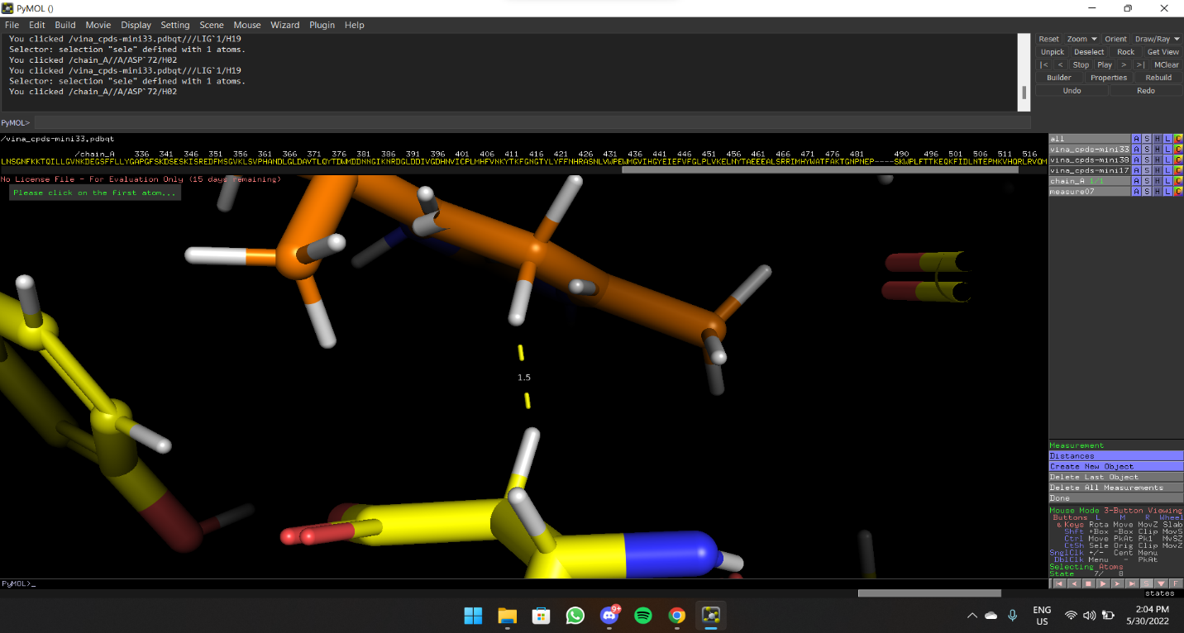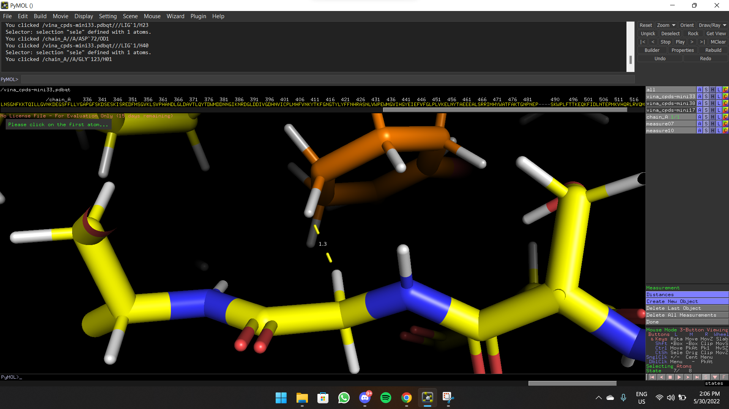

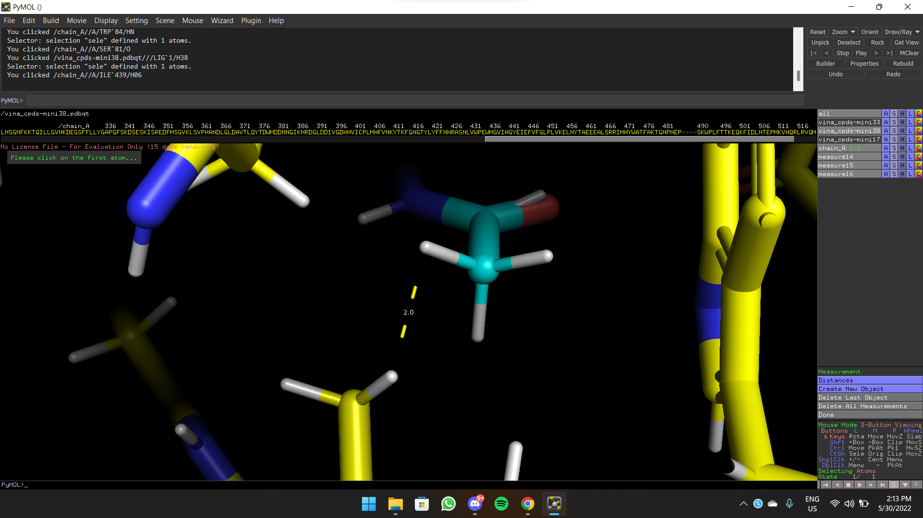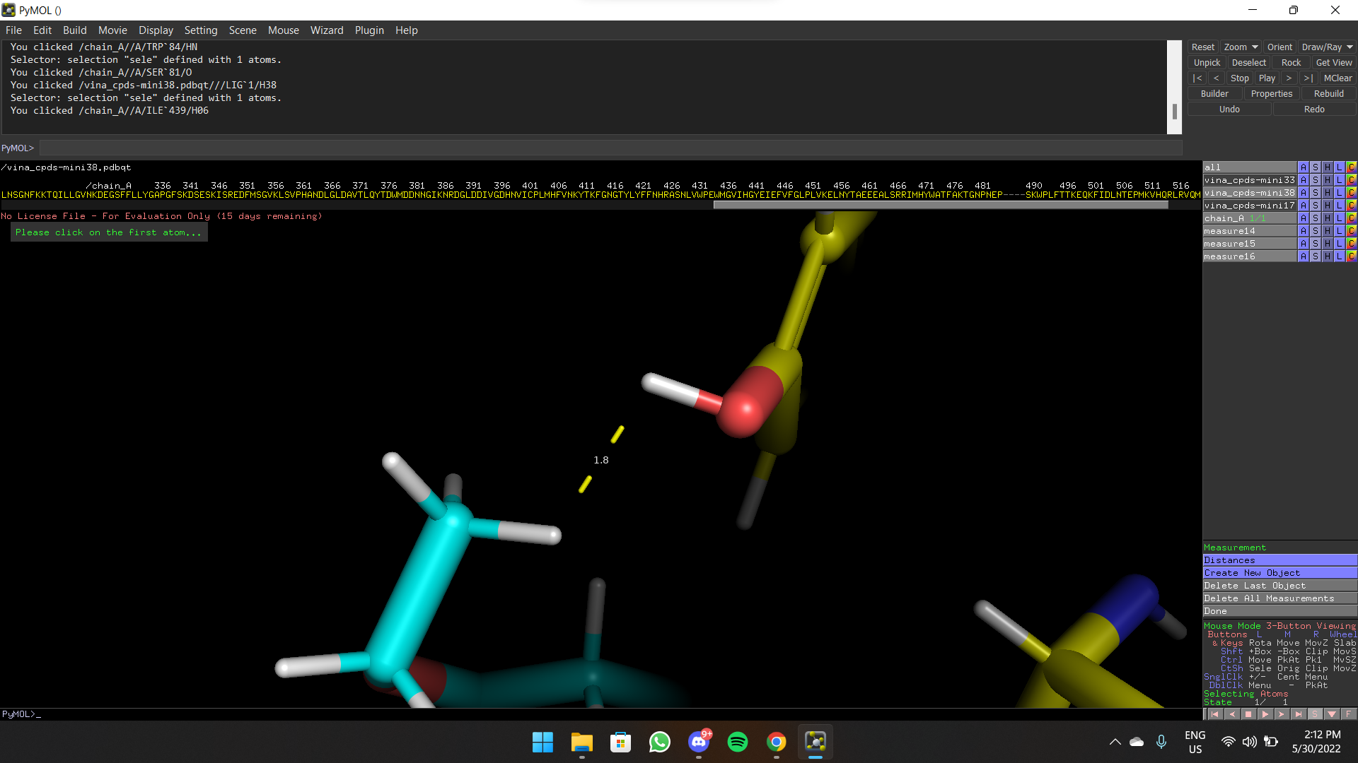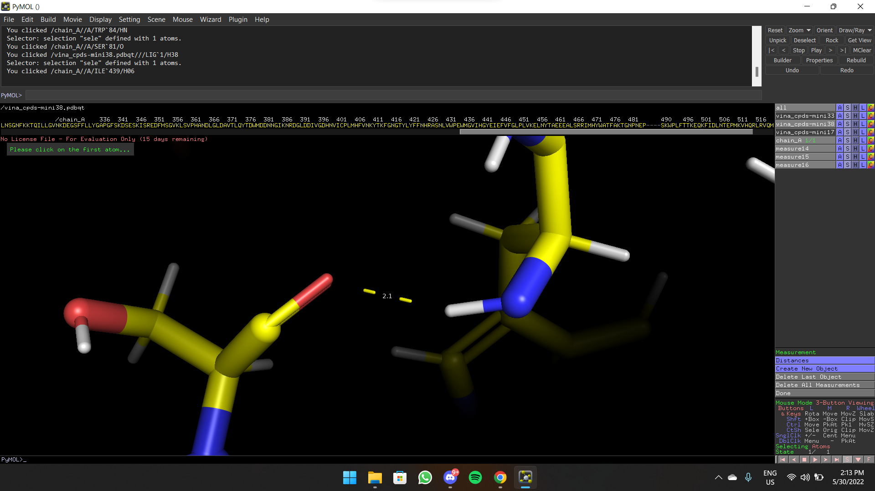

**Conclusion**

The length between bonds of both ligand 17 and 33 are near to each other as the affinity score is so close.